Garcia, Cayden

H||L Roulette Game Manual

Contents

Background and Overview 1

Domain Background 1

Overview of the Product 1

What the Product Does 1

Scope of the Product 2

Target Audience 2

Assumptions 2

What the User Should Already Know 2

Requirements 3

Minimum Hardware and Software Requirements 3

For Users 3

For Developers 3

Goals and Purposes for the User 4

Product Functionalities 4

Design 6

Languages and Operating System 6

Programming Languages 6

Operating System 6

Data Structures 6

Major Modules 8

Node_2D 8

Title Screen 15

Options Menu 15

Tutorial Screen 16

Interface Design 17

Flow Chart 17

Main Menu 18

Options Menu 19

Tutorial Menu 19

Game Base 20

Higher or Lower Phase 20

Target Phase 21

Arrow Phase 22

Installation 23

User Installation Guide 23

Developer Setup Guide 23

Using the System 25

Launching the Game 25

Starting a New Game 25

Playing the Game 25

Winning and Replay Options 26

Tips for Success 26

Sample Sessions 27

Session 1: Casual Playthrough 27

Session 2: Reflex Challenge 29

Session 3: Advanced Playthrough with High Stakes 31

Modifications 33

1. Instructions for Modifying the Code 33

2. Code Conventions Used 34

3. Suggested Improvements for Future Versions 34

Troubleshooting 36

References 37

Appendix A – Source Code File Contents and Development Tool Screens 38

Title Screen 38

Options Menu 41

How To Play Screen 43

Main Game 44

# Background and Overview

Higher or Lower Roulette (H||L Roulette) is an innovative and interactive game designed to challenge players’ reflexes, decision-making, and intuition in a high-stakes environment. By merging the simplicity of guessing card values with the tension of reflex-based gameplay, H||L Roulette offers a unique experience that blends strategy with quick thinking. With its intuitive mechanics and visually striking animations, the game appeals to casual players and competitive gamers alike, delivering both entertainment and a test of skill.

This document presents a detailed overview of the game, highlighting its features, the scope of its development, the target audience, and the assumptions regarding the user’s familiarity with similar games.

## Domain Background

Higher or Lower-style games have long been a staple in casual gaming, offering players a chance to test their intuition in predicting card values. These games typically involve guessing whether the next card in a sequence will be of higher or lower value than the current one, creating a simple yet addictive experience. The addition of reflex challenges, such as target shooting or arrow-key input mechanics, elevates the gameplay by incorporating elements found in arcade and action games.

The idea of reflex-based mechanics in card games draws inspiration from reaction-training games, which have been popularized in both mobile and desktop gaming spaces. These mechanics challenge players to respond quickly to visual and auditory cues, creating an immersive experience that blends cognitive and motor skills. H||L Roulette combines these two genres, taking traditional card-guessing games to a new level by incorporating strategic, visual, and reflex-based elements.

## Overview of the Product

### What the Product Does

H||L Roulette starts with a guessing phase, where players predict whether their card value will be higher or lower than their opponent's card. The game transitions to a reflex challenge in Phase 2. In this phase:

1. If the player’s guess is correct, they must click on specific targets on the screen within a limited timeframe to "secure" their victory.
2. If the guess is incorrect, they must press arrow keys in rapid succession to avoid penalties

This two-phase structure ensures that gameplay remains dynamic and engaging, rewarding both intuitive thinking and physical reflexes. The game's mechanics are designed to keep players on their toes, emphasizing a mix of luck, strategy, and skill.

### Scope of the Product

H||L Roulette is envisioned as a single-player game designed for mobile and desktop platforms, catering to casual gamers and enthusiasts of fast-paced, reflex-driven games. Future updates may include multiplayer modes, leaderboards, or customizable settings to enhance replayability.

The current scope includes:

* A visually striking card-guessing phase with animations that introduce the gameplay.
* A reflex-based second phase with mechanics such as clicking targets or pressing arrow keys based on in-game outcomes.
* Sound effects and visual cues to enhance player engagement.
* A health or point system to track player progress and performance.

### Target Audience

The primary audience for H||L Roulette includes:

* **Casual Gamers**: Players seeking quick, engaging sessions with minimal setup or learning curves.
* **Competitive Gamers**: Those interested in improving reflexes and decision-making under pressure.
* **Fans of Arcade and Reaction-Based Games**: Enthusiasts of games that combine skill-based challenges with interactive mechanics.

The game’s intuitive design ensures that it appeals to a broad demographic, including younger players interested in arcade-style gaming and older players drawn to card-based games with a modern twist.

## Assumptions

### What the User Should Already Know

To maximize enjoyment of H||L Roulette, it is assumed that the user has:

1. **Basic Knowledge of Card Games**: Familiarity with concepts like card ranks and sequences.
2. **Experience with Arcade Games**: Understanding of reaction-based mechanics, such as clicking targets or pressing keys in a timed setting.
3. **Basic Gaming Skills**: The ability to use a mouse or keyboard comfortably for interacting with the game.

# Requirements

The development and operation of Higher or Lower Roulette (H||L Roulette) require specific hardware and software configurations to ensure optimal performance and seamless gameplay. This section identifies the minimum requirements for users and developers, outlines the goals and purposes for players, and details the core functionalities that define the game. These requirements serve as a guide for building and maintaining a successful product tailored to the needs of its target audience.

## Minimum Hardware and Software Requirements

### For Users

H||L Roulette is designed exclusively for Windows-based systems, making it essential for users to meet the following specifications to enjoy smooth gameplay:

* **Hardware**:
  + Operating System: Windows 10 or newer (64-bit).
  + Processor: Dual-core 2 GHz or faster (Intel Core i3 or equivalent).
  + RAM: 4 GB or more.
  + Graphics: Integrated GPU capable of rendering 2D animations (e.g., Intel HD Graphics 4000 or newer).
  + Storage: At least 500 MB of free disk space.
  + Display: A minimum screen resolution of 1280x720.
  + Input: Keyboard and mouse or equivalent peripherals.
* **Software**:
  + Required Libraries: DirectX 12 or newer.
  + Dependencies: .NET Framework 4.8 or higher for runtime support.
  + Game Installer: Executable setup file compatible with Windows systems.

### For Developers

Developing H||L Roulette demands robust hardware and software to accommodate coding, testing, and rendering processes. The following are the recommended developer requirements:

* **Hardware**:
  + Operating System: Windows 10 or newer (64-bit).
  + Processor: Quad-core 3.0 GHz or faster (Intel Core i5 or equivalent).
  + RAM: 16 GB or more.
  + Graphics: Dedicated GPU (e.g., NVIDIA GTX 1060 or better) for rendering high-quality animations.
  + Storage: At least 1 TB HDD or SSD with 100 GB of free space for project files and assets.
  + Peripherals: Dual monitors for multitasking, with a minimum resolution of 1920x1080.
* **Software**:
  + Development Environment: Godot Engine 4.0 or newer.
  + Programming Tools: Integrated Development Environment (IDE) like Visual Studio Code.
  + Version Control: Git for collaboration and project management.
  + Asset Tools: Image editing software (e.g., GIMP, Photoshop) and audio editing software (e.g., Audacity).
  + Testing Tools: Debugging tools and performance profiling software.

### Goals and Purposes for the User

The primary objectives of H||L Roulette are to entertain players while offering challenges that engage their cognitive and reflexive skills. The following goals and purposes highlight the player-centric design of the game:

* **Entertainment**: Provide a captivating experience that combines strategy, intuition, and reaction-based gameplay.
* **Skill Development**: Enhance players' decision-making and hand-eye coordination through dynamic challenges.
* **Replayability**: Offer varied outcomes and mini-games to encourage repeated playthroughs and sustained interest.
* **Accessibility**: Design the game to be approachable for players of all skill levels, with clear instructions and intuitive controls.
* **Engagement**: Foster excitement through visually appealing animations, sound effects, and an interactive user interface.

### Product Functionalities

The core functionalities of H||L Roulette ensure an engaging and feature-rich experience. These include:

1. **Card-Guessing Mechanics**:
   * Present players with a card and allow them to guess whether the next card will be higher or lower.
   * Randomized card order to maintain unpredictability.
2. **Phase Two Reflex Challenges**:
   * **For Correct Guesses**:  
     Players must quickly click on targets that appear on the screen within a limited time.
   * **For Incorrect Guesses**:  
     Players are required to press arrow keys in the correct sequence to avoid penalties such as losing points or health.
3. **Health and Scoring Systems**:
   * Track players’ progress using a health bar and a score counter.
   * Deduct points or health for incorrect actions and reward points for successful challenges.
4. **Interactive Animations**:
   * Smooth card animations and transitions enhance visual appeal.
   * Dynamic feedback for actions such as correct or incorrect guesses.
5. **Sound Effects and Music**:
   * Background music to create an immersive atmosphere.
   * Sound cues to guide players through challenges and indicate outcomes.
6. **User-Friendly Interface**:
   * Simple and intuitive layout, ensuring players can navigate menus and understand gameplay mechanics without extensive tutorials.

# Design

The design of Higher or Lower Roulette (H||L Roulette) is integral to its development, as it outlines the technologies, data structures, and code modules that form the foundation of the game. This section provides an overview of the programming languages and operating system selected for the project, an outline of data structures and how data is stored, and a detailed description of the major code modules used in development. By breaking the design into these components, we ensure the game is built on robust, scalable, and maintainable architecture.

## Languages and Operating System

### Programming Languages

H||L Roulette is developed using the following languages:

* **GDScript**:
  + The primary scripting language of the Godot Engine.
  + Selected for its seamless integration with the engine and ease of use for game logic.
  + Provides high-level control over animations, input handling, and gameplay mechanics.
* **Python** (Optional for supplementary tools):
  + Used for auxiliary tasks such as asset management or pre-processing data.
  + Chosen for its simplicity and wide array of libraries.

### Operating System

* **Windows 10/11 (64-bit)**:
  + Selected as the exclusive platform for H||L Roulette due to its widespread usage and robust support for gaming.
  + Provides access to powerful development tools and hardware compatibility.
  + Ensures performance optimization for a large segment of the gaming audience.

## Data Structures

* **Card data**
  + Stores details of a standard 52-card deck, including suits and values
  + List
  + Outline:



* + Card assignments to player and UNK:

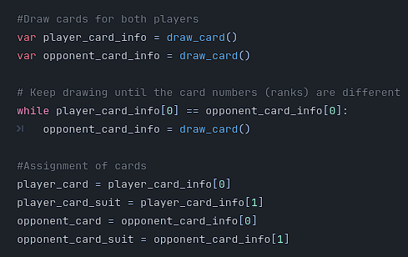

* **Game state**
  + Track current games difficulty
  + String
  + Setting difficulty:

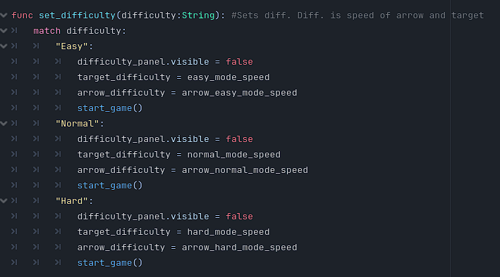

## Major Modules

### Node_2D

* **Main Game Loop**
  + “_ready”
    - Loads all scene assets when game starts



* + “start_game”
    - Starts the game

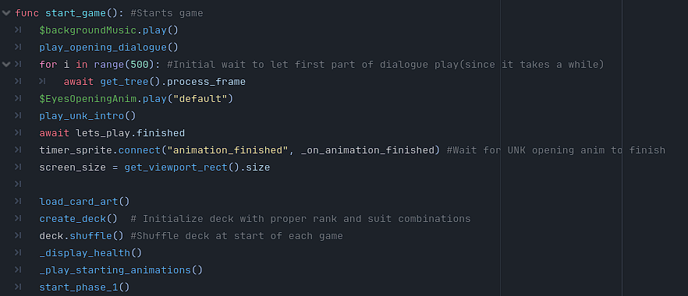

* + “set_difficulty”
    - Sets difficulty for current session
* **On startup**
  + “create_deck”
    - Creates deck for play session

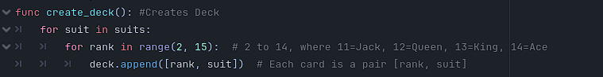

* + “_game_over”
    - Handles game over logic

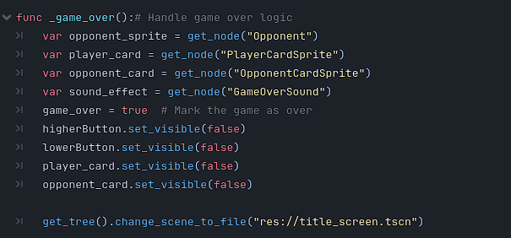

* **Phase 1** 
  + “start_phase_1”
    - Starts new round by drawing player and opponent cards

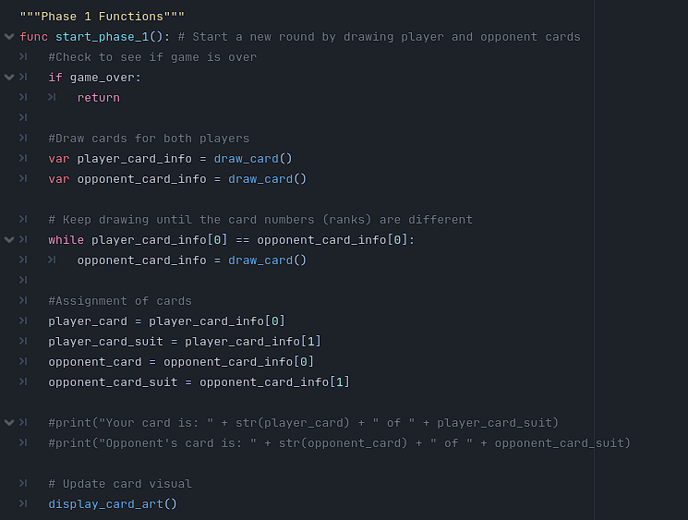

* + “draw_card”
    - Draws cards for both player and UNK for the round

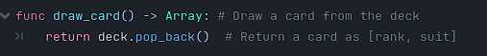

* + “new_player_guess”
    - Handles player’s guess (higher or lower)

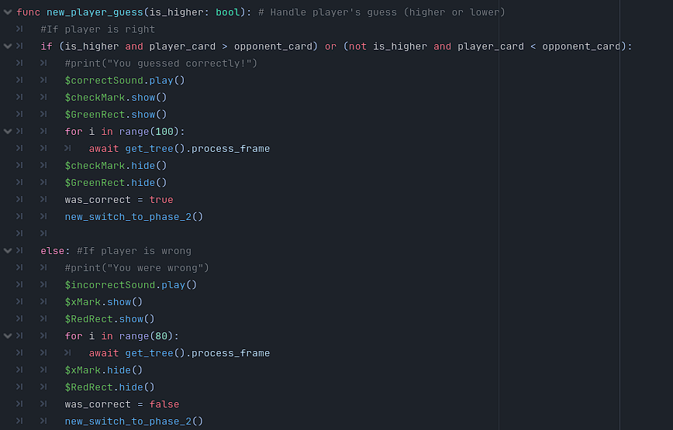

* + “unk_card_choice_outcome”
    - Handles outcome of UNK’s choice, true if he was right, false if he was wrong

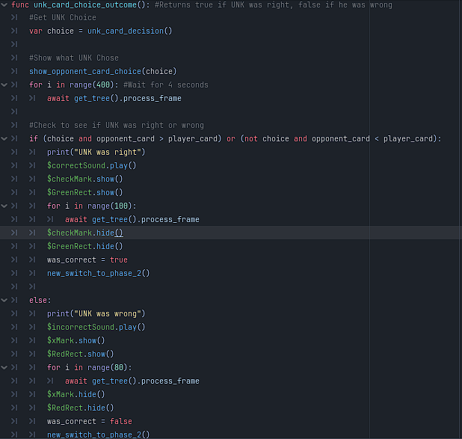

* **Phase 2**
  + “new_switch_to_phase_2”
    - Handles switch from phase 1 to phase 2

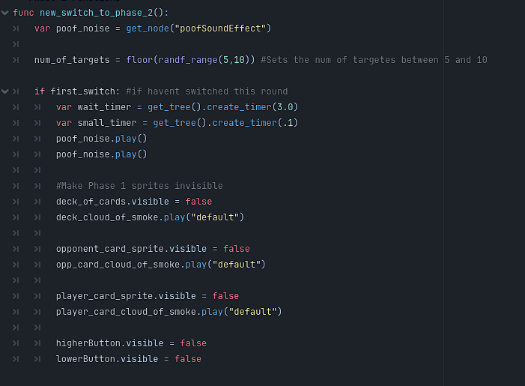

* + “new_start_phase_2”
    - Checks if current guesser was right or wrong,
    - Starts phase 2

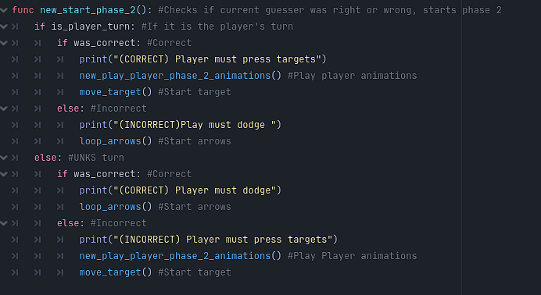

* + “move_target”
    - Moves target in random positions around screen
    - Checks to see if there are any targets left
  + “_on_target_pressed”
    - Checks to see if target is clicked

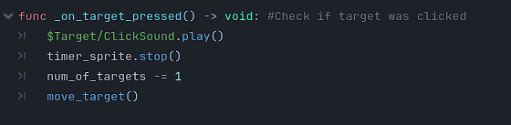

* + “make_arrow_fall”
    - Decides which arrow should be falling

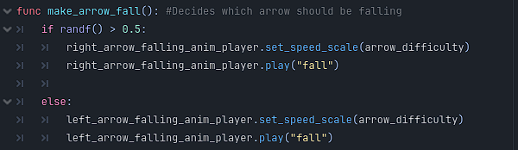

* + “_input”
    - Gets the arrow key input from the user

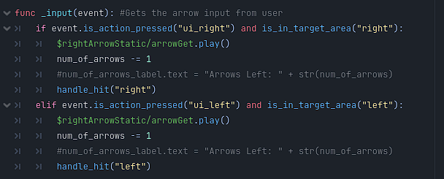

* + “is_in_target_area”
    - Check to see if the arrow that fell was pressed in time

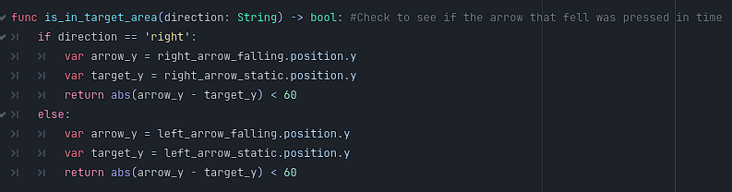

* + “handle_hit”
    - Handles user input

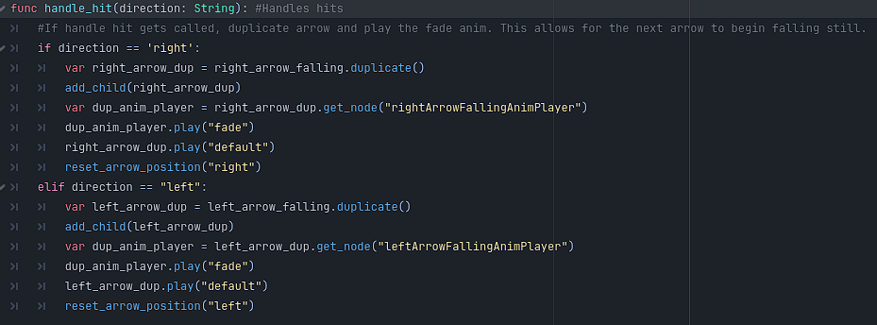

* **Health**
  + “_check_player_lives”
    - Checks player lives to see if player is out of health or not
  + “_check_opp_lives”
    - Checks UNKS lives to see if UNK if out of health or not
  + “_display_health”
    - Updates health visually on screen
* **Animations**
  + “play_unk_intro”
    - Playes UNK opening animations
  + “play_unk_throw”
    - Plays UNK ball throwing animation
* **Dialogue**
  + “play_opening_dialogue”
    - Plays entire opening sequence dialouge

### Title Screen

* **Vertical Box Container:**
  + Contains all buttons that will take the user to different screens
    - “Play” button
      * Starts the game
    - “Free play” button
      * Starts the game with no story
    - “Options” button
      * Opens up the settings page
    - “Tutorial” button
      * Opens up tutorial page so user can see how to play
    - “Quit” button
      * Quits the game

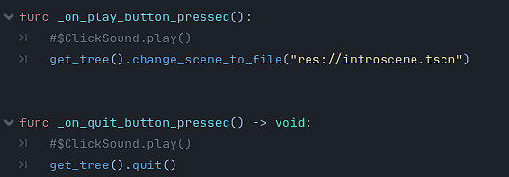

### Options Menu

* **Vertical Box Container**
  + Volume Slider
    - Controls the volume of the game
  + Resolution button
    - Controls what size the resolution is
  + Fullscreen Checkbox
    - Controls whether or not the game is full screen
  + Save Button
    - Saves new options for current session

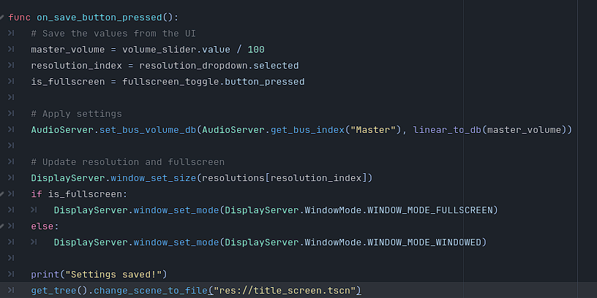

### Tutorial Screen

* Videos showing how to play each section

## Interface Design

### Flow Chart

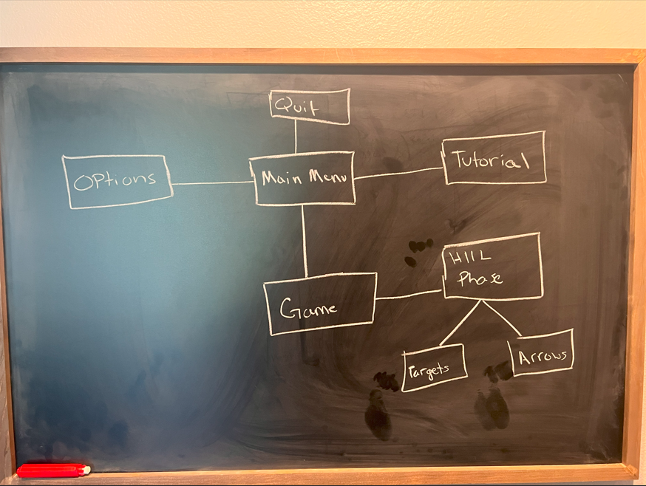

### Main Menu

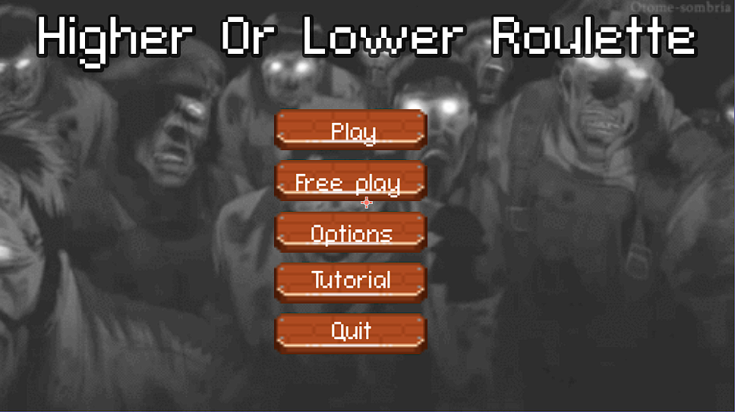

### Options Menu

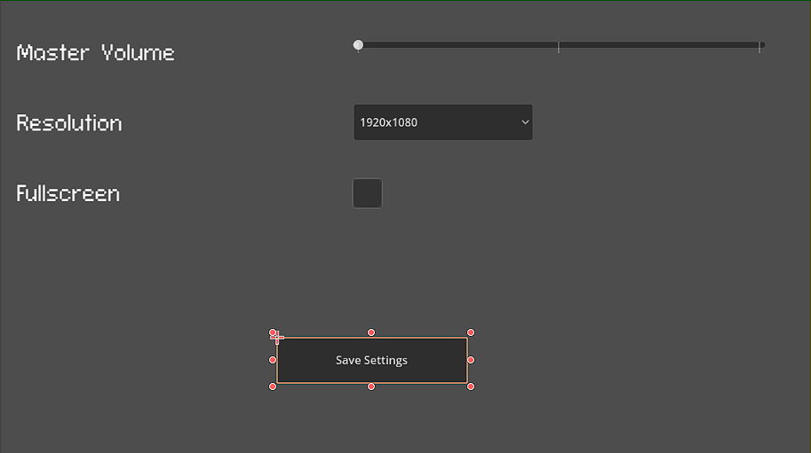

### Tutorial Menu

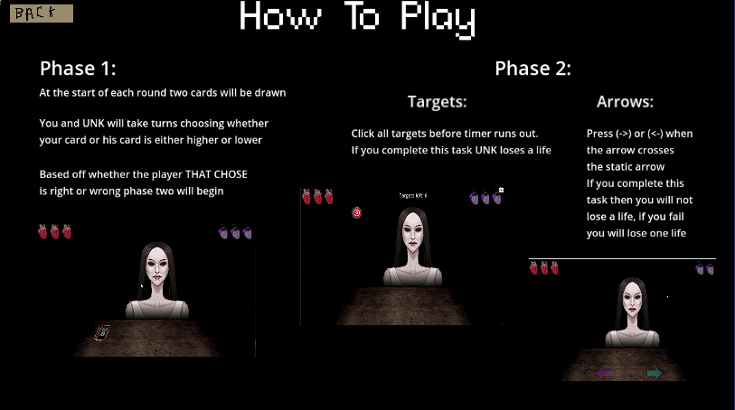

### Game Base

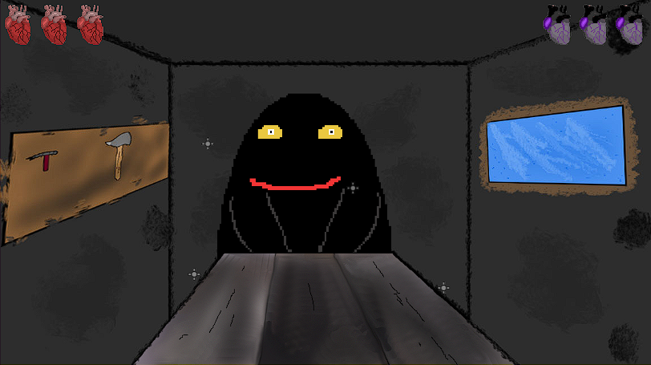

### Higher or Lower Phase

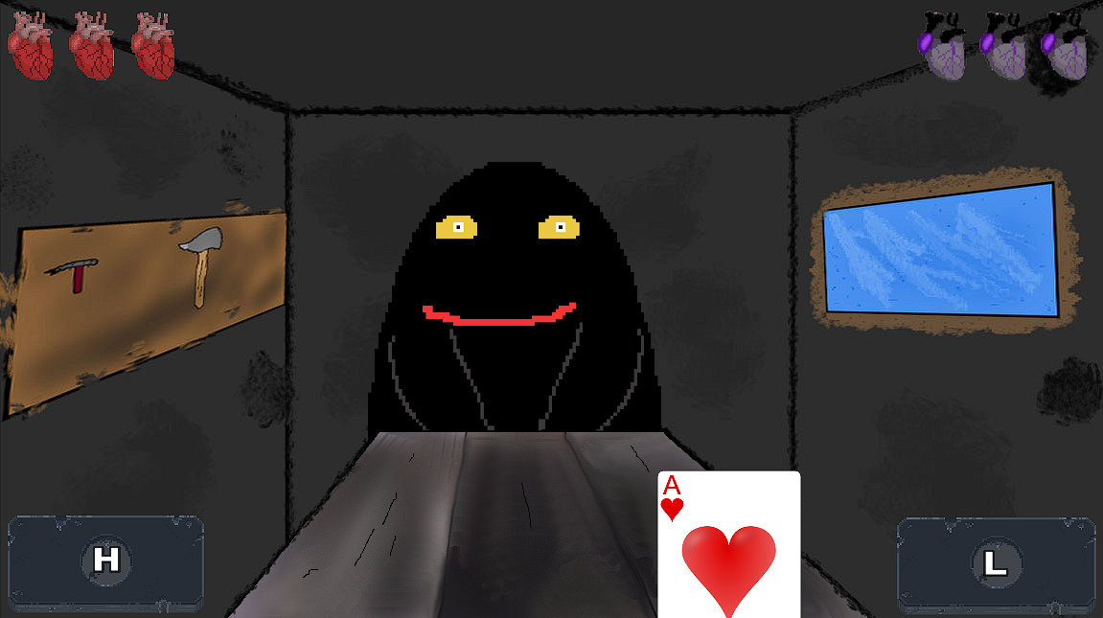

### Target Phase

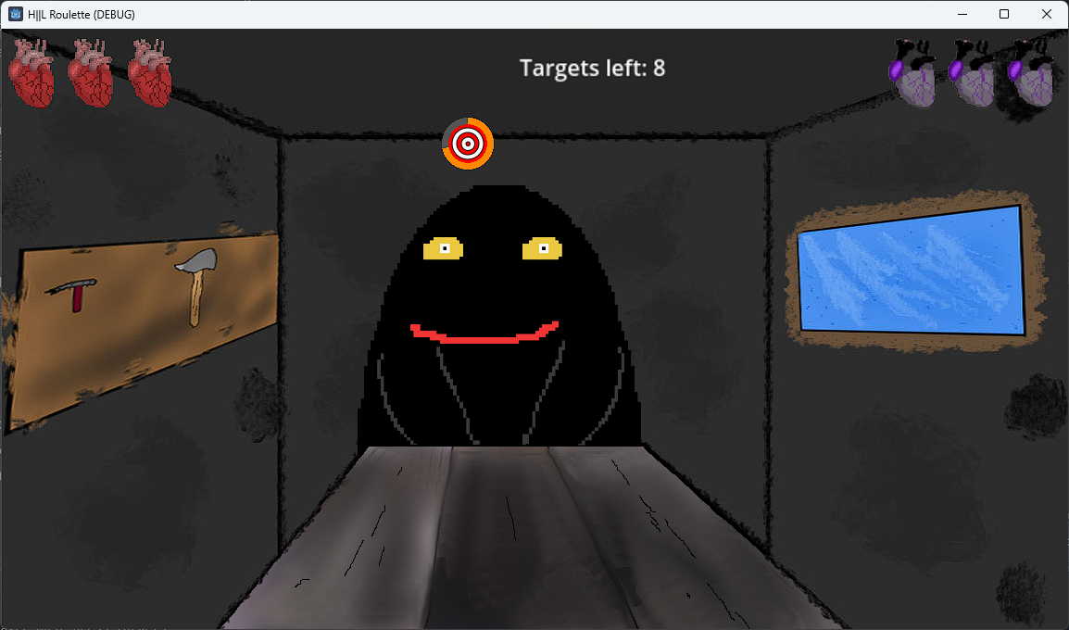

### Arrow Phase

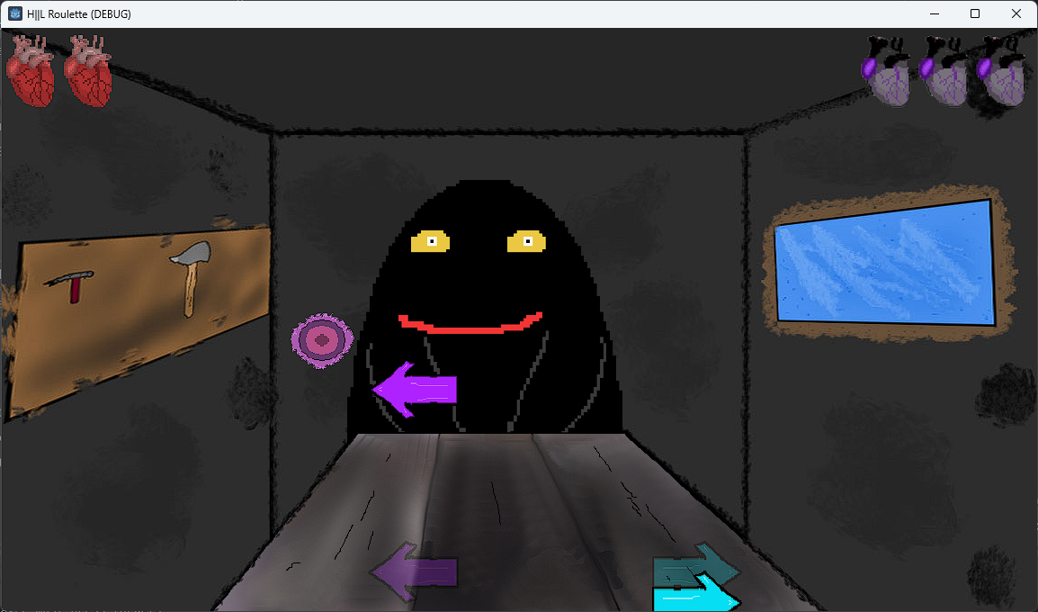

# Installation

The installation process for Higher or Lower Roulette (H||L Roulette) is designed to be straightforward for both players and developers. This section provides step-by-step instructions for users to install and run the game and for developers to set up the environment required for development. It also lists the source code files, their organization, and the development tools necessary for building the game.

## User Installation Guide

**1. System Requirements**

Ensure your system meets the following minimum requirements before installation:

* **Operating System**: Windows 10/11 (64-bit).
* **Hardware**: 4 GB RAM, Dual-core processor, and at least 500 MB of free storage.

**2. Download the Game**

* Visit the official website or the provided link to download the game installer (e.g., HLLRoulette_Setup.exe).
* Save the installer to a preferred location on your computer.

**3. Install the Game**

* Double-click the downloaded setup file (HLLRoulette_Setup.exe).
* Follow the on-screen instructions to complete the installation.
  + Choose an installation directory (e.g., C:\Program Files\HLLRoulette).
  + Confirm any prompts to allow the installer to make changes to your system.

**4. Run the Game**

* After installation, locate the game shortcut on your desktop or in the installation directory.
* Double-click the shortcut to launch the game.

## Developer Setup Guide

**1. System Requirements**

Ensure your system meets the following recommended requirements:

* **Operating System**: Windows 10/11 (64-bit).
* **Hardware**: 16 GB RAM, Quad-core processor, and 100 GB of free storage.

**2. Source Code Files**

The source code for H||L Roulette is organized as follows:

* **Root Directory**: Contains the main project file for Godot Engine (e.g., HLLRoulette.project).
* **Folders**:
  + scripts/: GDScript files for game logic (e.g., GameLoop.gd, InputManager.gd).
  + assets/: Includes images, audio files, and animations.
  + scenes/: Godot scene files for different game phases.

**3. Obtaining the Source Code**

* Clone or download the project repository from the official GitHub repository (provide the URL).
  + Example:

*git clone https://github.com/YourRepo/HLLRoulette.git*

* Extract the contents if downloaded as a ZIP file, and place them in a working directory (e.g., C:\HLLRoulette).

**4. Install Development Tools**

* **Godot Engine 4.0 or Newer**:
  + Download from the official Godot Engine website.
  + Install it on your system and verify it is working by running the application.
* **Version Control**:
  + Install Git for managing source code versions (optional for collaboration).
  + Download Git from [git-scm.com](https://git-scm.com/) and follow the installation instructions.
* **Optional Tools**:
  + Install a code editor like Visual Studio Code for editing GDScript files.
  + Download image and audio editing tools like GIMP and Audacity for asset creation.

**5. Setting Up the Project**

* Open Godot Engine and click on "Import Project."
* Navigate to the directory where the source code is stored and select HLLRoulette.project.
* Once imported, review the project settings to confirm paths to assets and dependencies are correct.

**6. Running the Game for Development**

* Inside Godot, press the **Play** button to run the game directly from the editor.
* Debug issues and adjust scripts or assets as needed.

# Using the System

Once H||L Roulette is installed on your preferred device, follow these steps to start and enjoy the game. Below is a short user’s manual to guide you through the process.

## Launching the Game

1. **Locate the Application**: On your desktop or mobile device, find the H||L Roulette icon and click or tap to open the game.
2. **Access the Main Menu**: Upon launch, you will be presented with the main menu, where you can select the following options:
   * **Start Game**: Begin a new session.
   * **Settings**: Adjust audio, visual, or difficulty settings.
   * **How to Play**: View a quick tutorial or recap of the game mechanics.
   * **Exit**: Close the game (for desktop versions only).

## Starting a New Game

1. **Select Your Preferences**: Before the game starts, you may be prompted to choose:
   * Difficulty level (Easy, Medium, Hard).
   * Audio settings or background music preferences.
2. **Begin the Guessing Phase**:
   * A card will be dealt to you, and the opponent's card will remain face down.
   * Use the **Higher** or **Lower** buttons to predict if your card value is greater or smaller than your opponent’s card.
   * Confirm your guess to proceed.

## Playing the Game

1. **Phase 1: Card Guessing**
   * Observe your card and make a prediction.
   * The game will reveal the opponent's card after your guess.
   * Outcomes:
     + **Correct Guess**: You advance to the **Target Shooting Challenge** in Phase 2.
     + **Incorrect Guess**: You enter the **Arrow Key Reflex Challenge** in Phase 2.
2. **Phase 2: Reflex Challenge**
   * **Target Shooting Challenge** (for correct guesses):
     + Click on the targets displayed on the screen within the allotted time.
     + Each successful click secures points and maintains your progress.
   * **Arrow Key Reflex Challenge** (for incorrect guesses):
     + Follow the on-screen prompts to press arrow keys in the correct sequence.
     + Failing to complete the sequence in time will result in a penalty, such as losing health or points.
3. **Health Tracking**
   * Your health is displayed on-screen.
   * Avoid penalties to preserve health

## Winning and Replay Options

1. **Win Conditions**: The game ends when:
   * You deplete your opponent’s health through successful phases.
   * You achieve the maximum score possible in the session.
2. **Game Over**: If your health reaches zero, the game ends. You can return to the main menu to restart or adjust settings.
3. **Replayability**:
   * Access leaderboards (if available) to track your performance against others.
   * Try different difficulty levels to challenge yourself further.

## Tips for Success

* Take a moment to analyze your card before making predictions in Phase 1.
* Keep your hands positioned comfortably near your mouse or keyboard to react quickly in Phase 2.
* Pay attention to the sound and visual cues to anticipate upcoming challenges.

# Sample Sessions

Below is a detailed walkthrough of typical sessions with **H||L Roulette**, demonstrating the core functionalities of the game. Screenshots are supplemented with explanations to provide clarity. Each screen represents a distinct stage in the gameplay.

## Session 1: Casual Playthrough

**1. Main Menu**  
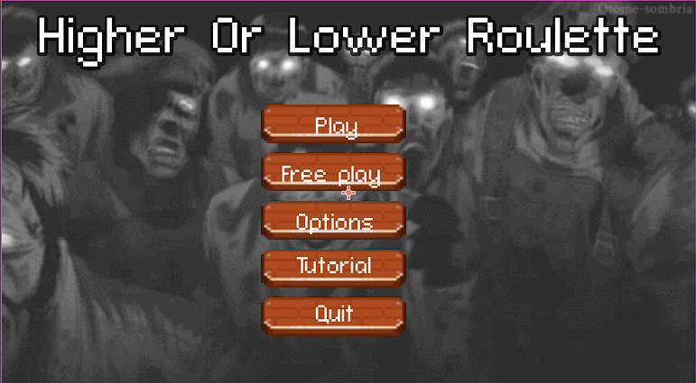

**Description**: The main menu greets the player with options such as **Start Game**, **Settings**, **How to Play**, and **Exit**. Here, the player selects **Start Game** to begin a new session.

**2. Card Guessing Phase**  


**Description**: The player’s card (e.g., 7 of Hearts) is revealed on the left, while the opponent's card remains face down on the right. The player predicts that the opponent's card will be **Higher** and confirms their choice by clicking the corresponding button.

**3. Outcome of Card Guessing**  
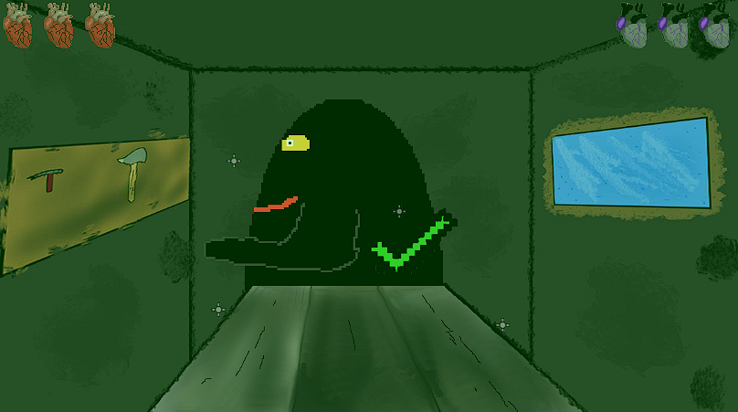  
**Description**: The opponent's card (e.g., Jack of Clubs) is revealed, confirming the player’s correct prediction. The game transitions to the **Target Shooting Challenge** in Phase 2 as a reward.

## Session 2: Reflex Challenge

**1. Target Shooting Challenge**  


**Description**: Several targets appear on the screen. The player quickly clicks on the targets within the time limit, earning points for each successful hit. A progress bar tracks their performance.

**2. Incorrect Guess Leading to Arrow Key Challenge**  
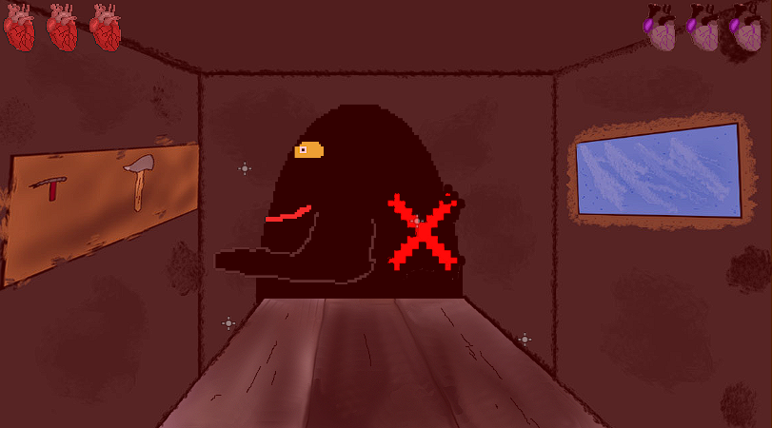

**Description**: After an incorrect guess in the previous phase, the player must press the arrow keys in the correct sequence shown on the screen. Timely inputs prevent health loss, while missed inputs result in penalties.



## Session 3: Advanced Playthrough with High Stakes

**1. Adjusting Settings**  
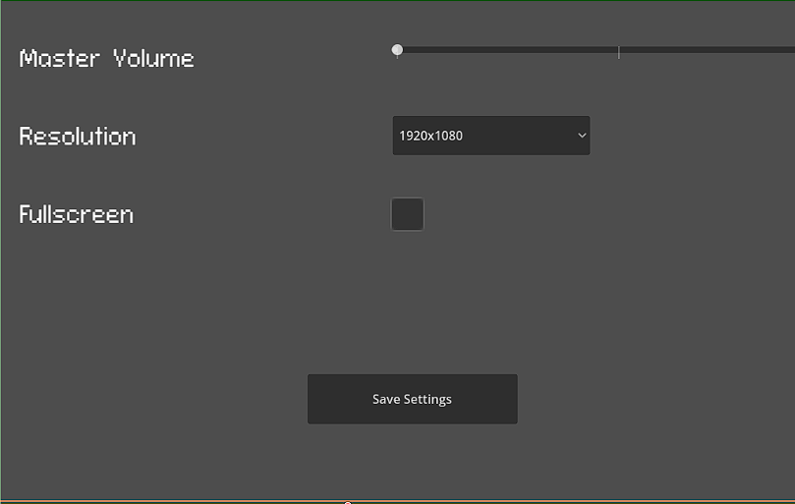  
**Description**: Before starting the game, the player selects **Settings** from the main menu to increase the edit their settings for the current session

**2. Mid-Game Decision-Making**



**Description**: With low health remaining, the player carefully considers whether to predict **Higher** or **Lower**. This adds a strategic dimension to their choice, factoring in the likelihood of the opponent’s card value.

**3. Winning Screen**  
  
**Description**: The player successfully completes the session by depleting the opponent’s health or achieving the highest possible score. A congratulatory screen displays their performance summary and awards.

# Modifications

This section provides a guide for modifying the existing codebase of **H||L Roulette** to introduce enhancements or fix potential issues. It includes instructions on making changes, conventions followed in the code, and thoughtful suggestions for improvements in future versions.

## 1. Instructions for Modifying the Code

The **H||L Roulette** codebase is structured to ensure modularity and ease of modification. Key components of the code are divided into separate files for readability and maintainability. Here’s how to approach changes:

**a. Setting Up the Development Environment**

1. Ensure you have **Godot Engine 4.x** installed and configured on your system.
2. Open the project directory in Godot. The folder structure will include:
   * Scripts/: Contains all game logic scripts.
   * Scenes/: Includes the user interface and gameplay elements.
   * Assets/: Stores graphics, audio files, and animations.
3. Load the project using Godot’s editor, and navigate to the relevant scripts or scenes for modifications.

**b. Making Changes to Gameplay Logic**

* The primary gameplay logic is contained in Scripts/GameManager.gd.
* **Example: Adjusting Phase Timers**:  
  To change the timer for reflex challenges, locate the start_phase_2 function in GameManager.gd. Modify the time_limit parameter:

var time_limit = 5 # Change this value to adjust the reflex phase duration.

**c. Modifying UI Elements**

* UI-related changes can be made in the Scenes/UI.tscn file.
* **Example: Adding a New Button**:  
  To add a button, open UI.tscn in the Godot editor, add a Button node, and connect it to the appropriate script in Scripts/UIManager.gd. Use the following template for the script connection:

func _on_new_button_pressed():

print("New button clicked!")

**d. Adding New Animations**

* Animations are managed using AnimationPlayer nodes in the Scenes/Animations/ folder.
* To add a new animation, use the AnimationPlayer in the Godot editor. Create a new animation track and keyframe the desired properties (e.g., position, scale, or opacity).

## 2. Code Conventions Used

To maintain a clean and consistent codebase, the following conventions were adhered to:

**a. Naming Conventions**

* **Variables**: Use snake_case for variable names, e.g., player_health.
* **Functions**: Use snake_case for function names, e.g., start_game.
* **Constants**: Define constants in uppercase, e.g., MAX_HEALTH.
* **Node Names**: Use PascalCase for scene node names, e.g., PlayerCard.

**b. Code Organization**

* Scripts are organized based on their functionality:
  + GameManager.gd: Manages overall game flow.
  + Player.gd and Opponent.gd: Handle player and AI logic.
  + UIManager.gd: Manages the user interface.
* Comments are added to each major function for clarity, e.g.:

# This function handles the transition to the reflex phase.

func start_phase_2():

pass

**c. Error Handling**

* Defensive programming is used to prevent runtime errors. For instance:

if card_deck.size() == 0:

print("Error: Deck is empty!")

return

## 3. Suggested Improvements for Future Versions

To enhance **H||L Roulette**, the following updates could be implemented:

**a. Multiplayer Mode**

* **Description**: Allow players to compete against each other in real-time, increasing the replayability and competitive appeal.
* **Implementation**: Use Godot’s networking capabilities to sync player actions and card data between clients.

**b. Improved AI for Opponents**

* **Description**: Make the AI smarter by incorporating additional decision-making factors, such as tracking the player’s habits or considering probabilities in the guessing phase.
* **Implementation**: Extend the AI logic in Opponent.gd to analyze player behavior over multiple rounds.

**c. Enhanced Visual Feedback**

* **Description**: Add more dynamic animations, particle effects, and screen shake to increase the visual appeal.
* **Implementation**: Use Godot’s animation tools and particle nodes to create these effects, triggering them during key gameplay events like correct guesses or penalties.

**d. Accessibility Features**

* **Description**: Introduce colorblind modes, adjustable font sizes, and customizable controls to make the game more inclusive.
* **Implementation**: Add settings in UIManager.gd to allow players to toggle accessibility options.

**e. Achievements and Leaderboards**

* **Description**: Introduce an achievement system and global leaderboards to motivate players and enhance the competitive aspect.
* **Implementation**: Use an external service or database to track player scores and progress.

**f. Customizable Game Modes**

* **Description**: Let players adjust game settings, such as card deck size or reflex phase difficulty, for a personalized experience.
* **Implementation**: Expand the settings menu in UI.tscn to include sliders and toggles for these options.

# Troubleshooting

Below is a table outlining common problems or errors encountered while using H||L Roulette and their respective causes and solutions. This section covers gameplay issues, general software errors, and common operating system-related problems.

|  |  |  |
| --- | --- | --- |
| **Symptom** | **Cause** | **Solution** |
| **Game crashes on startup** | **Missing or corrupted game files.** | **Reinstall the game and ensure all required files are present.** |
| **Black screen on launch** | **Graphics card drivers are outdated.** | **Update graphics drivers to the latest version and restart the system.** |
| **Game freezes during gameplay** | **Insufficient system memory or too many background applications running.** | **Close unnecessary applications and ensure the system meets the minimum requirements.** |
| **Animation skips or lags** | **Graphics settings are too high for the current hardware.** | **Lower graphics settings in the game options menu.** |
| **Cards do not display properly** | **Missing or corrupted asset files, such as card images.** | **Verify game files or reinstall the game to restore missing assets.** |
| **Player card overlaps opponent card** | **Bug in card rendering logic.** | **Update to the latest game version where the issue has been patched.** |
| **Controls not responding** | **Input devices (keyboard/mouse) are not detected or improperly configured.** | **Check the device connection, ensure they are functional, and configure controls in settings.** |

# References

1. **Godot Engine Documentation.** (2024). *Godot 4 Documentation*. https://docs.godotengine.org/en/stable/.
2. **Mitchell, C.** (2023). *Learning Godot: Game Development in Python and GDScript*. Packt Publishing. <https://www.packtpub.com/>.
3. **Godot Engine Community.** (2024). *Godot Engine: Understanding the Scene System*. https://godotengine.org/community.
4. **Godot Engine Documentation.** (2024). *Animation in Godot*. https://docs.godotengine.org/en/stable/tutorials/animation/.
5. **Stemmle, M.** (2020). *Game Design and Development with Godot 3.0*. Springer. <https://www.springer.com/>.
6. **Sutherland, A.** (2022). *Making Games with Godot: Mastering the Game Development Process*. Apress. <https://www.apress.com/>.
7. **Wilson, J.** (2023). *Building 2D Games with Godot*. O'Reilly Media. <https://www.oreilly.com/>.
8. **Soma Games.** (2019). *A Study of Buckshot Roulette Mechanics and Design*. <https://somagames.com/>.
9. **Kreiger, T.** (2021). *Buckshot Roulette: A Detailed Look at Card-Based Roulette Mechanics*. Game Developer Journal, 15(2), 34-47. <https://www.gamedeveloper.com/>.
10. **Vigna, P.** (2021). *The Evolution of Card-Based Games in Interactive Media*. MIT Press. <https://mitpress.mit.edu/>.
11. **Hernandez, E.** (2021). *Designing Unique Gambling Games: The Case of Buckshot Roulette*. Springer. <https://www.springer.com/>.
12. **Toby Fox.** (2015). *Undertale: A Revolutionary Role-Playing Game*. <https://undertale.com/>.
13. **Fox, T.** (2016). *Undertale: The Art of Minimalist RPG Design*. Game Design Quarterly, 14(3), 25-40. <https://gamedesignquarterly.com/>.
14. **Toby Fox.** (2023). *Undertale Developer Commentary*. https://undertale.com/creator-comments/.
15. **Baker, D.** (2017). *Undertale: Storytelling through Mechanics*. Game Studies Journal, 19(1), 5-18. <https://www.gamestudies.org/>.

# Appendix A – Source Code File Contents and Development Tool Screens

Below is a complete listing of the source code for **Higher or Lower Roulette (H||L Roulette)**, including comments for each function, major variables, and complex sections of the code. The code is organized by the **assets** in the project, starting with the **Title Screen**, followed by the **Code**

### Title Screen

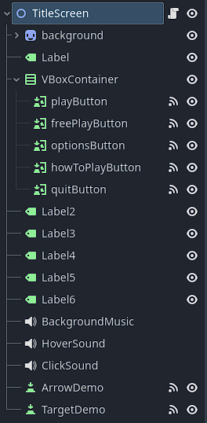

extends Node2D

# Called when the node enters the scene tree for the first time.

func _ready():

$background/AnimatedSprite2D.play() #Play background

#$BackgroundMusic.play()

# Called every frame. 'delta' is the elapsed time since the previous frame.

func _process(delta: float) -> void:

pass

func _on_play_button_pressed():

#$ClickSound.play()

get_tree().change_scene_to_file("res://introscene.tscn")

func _on_quit_button_pressed() -> void:

#$ClickSound.play()

get_tree().quit()

func _on_free_play_button_pressed() -> void:

#$ClickSound.play()

pass

func _on_options_button_pressed() -> void:

#$ClickSound.play()

get_tree().change_scene_to_file("res://optionsMenu.tscn")

func _on_how_to_play_button_pressed() -> void:

get_tree().change_scene_to_file("res://howToPlay.tscn")

func _on_play_button_mouse_entered() -> void:

$HoverSound.play()

func _on_free_play_button_mouse_entered() -> void:

$HoverSound.play()

func _on_options_button_mouse_entered() -> void:

$HoverSound.play()

func _on_quit_button_mouse_entered() -> void:

$HoverSound.play()

func _on_target_demo_pressed() -> void:

get_tree().change_scene_to_file("res://TargetDemo.tscn")

func _on_arrow_demo_pressed() -> void:

get_tree().change_scene_to_file("res://ArrowDemo.tscn")

### Options Menu

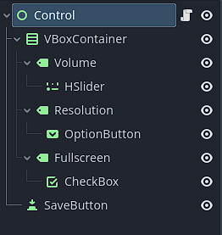

extends Control

#Variables to store settings

var master_volume = 1.0

var resolution_index = 0

var is_fullscreen = false

#Nodes for UI elements

@onready var volume_slider = $VBoxContainer/Volume/HSlider

@onready var resolution_dropdown = $VBoxContainer/Resolution/OptionButton

@onready var fullscreen_toggle = $VBoxContainer/Fullscreen/CheckBox

@onready var save_button = $SaveButton

#Resolutions available

var resolutions = [

Vector2(1920,1080),

Vector2(1280,720),

Vector2(800,600),

Vector2(1152,648)

]

func _ready():

#Set initial UI values

volume_slider.value = master_volume * 100

resolution_dropdown.clear()

for resolution in resolutions:

resolution_dropdown.add_item(str(resolution.x) + "x" + str(resolution.y))

resolution_dropdown.select(resolution_index)

fullscreen_toggle.button_pressed = is_fullscreen

save_button.connect("pressed", Callable(self,"on_save_button_pressed"))

func on_save_button_pressed():

# Save the values from the UI

master_volume = volume_slider.value / 100

resolution_index = resolution_dropdown.selected

is_fullscreen = fullscreen_toggle.button_pressed

# Apply settings

AudioServer.set_bus_volume_db(AudioServer.get_bus_index("Master"), linear_to_db(master_volume))

# Update resolution and fullscreen

DisplayServer.window_set_size(resolutions[resolution_index])

if is_fullscreen:

DisplayServer.window_set_mode(DisplayServer.WindowMode.WINDOW_MODE_FULLSCREEN)

else:

DisplayServer.window_set_mode(DisplayServer.WindowMode.WINDOW_MODE_WINDOWED)

print("Settings saved!")

get_tree().change_scene_to_file("res://title_screen.tscn")

### How To Play Screen

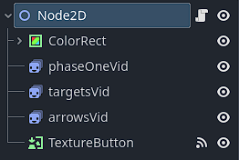

extends Node2D

func _ready():

$phaseOneVid.play()

$targetsVid.play()

$arrowsVid.play()

func _on_texture_button_pressed() -> void:

get_tree().change_scene_to_file("res://title_screen.tscn")

### Main Game

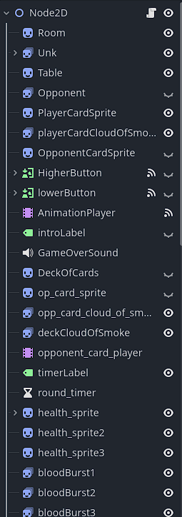

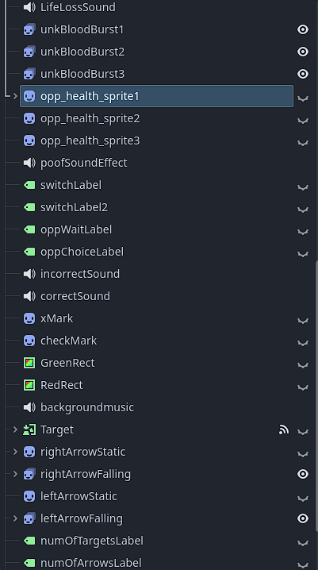

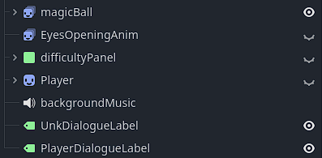

extends Node2D

"""Phase 1 variables"""

var deck = [] #LIST: deck of cards

var suits = ["hearts", "diamonds", "clubs", "spades"] #LIST: suits for cards

var card_sprites = {} #DICTIONARY: holds the card images as textures

var player_card = 0 #INT: player card

var player_card_suit = "" #Don't use

var opponent_card = 0 #INT: UNK Card

var opponent_card_suit = "" #Don't use

var is_player_turn = true #BOOL: player turn or not

var game_over = false #BOOL: game over or not

var player_lives = 3 #INT: player lives

var opp_lives = 3 #INT: UNK'S lives

"""Phase 2 variables"""

var first_switch = true #BOOL: first switch in round or not

var was_correct = true #BOOL: guesser was correct or not

var easy_mode_speed = .7 #DOUBLE: easy speed

var normal_mode_speed = 1.1 #DOUBLE: normal speed

var hard_mode_speed = 1.7 #DOUBLE: hard speed

var arrow_easy_mode_speed = .5 #DOUBLE: arrow easy speed

var arrow_normal_mode_speed = .8 #DOUBLE: arrow normal speed

var arrow_hard_mode_speed = 1 #DOUBLE: arrow hard speed

var screen_size #LIST: size of current screen(Resolution)

var num_of_targets = 0 #INT: number of targets for phase 2

var num_of_arrows = 0 #INT: number of arrows for phase 2

var arrow_animation_finished = false #BOOL: did player miss arrow or not

var arrow_difficulty = 0 #INT: how fast arrow will fall

var target_difficulty = 0 #INT: how fast target will dissapear

"""Phase 1 OnReady Sprites"""

@onready var difficulty_panel = $difficultyPanel

@onready var animation_player = $AnimationPlayer

@onready var higherButton = $HigherButton

@onready var lowerButton = $lowerButton

@onready var opponent_card_animation = $opponent_card_player

@onready var deck_of_cards = $DeckOfCards

@onready var player_card_sprite = $PlayerCardSprite

@onready var opponent_card_sprite = $op_card_sprite

@onready var deck_cloud_of_smoke = $deckCloudOfSmoke

@onready var opp_card_cloud_of_smoke = $opp_card_cloud_of_smoke

@onready var player_card_cloud_of_smoke = $playerCardCloudOfSmoke

"""Phase 2 on ready Sprites"""

@onready var target = $Target

@onready var timer_sprite = $Target/timerSprite

@onready var right_arrow_static = $rightArrowStatic

@onready var left_arrow_static = $leftArrowStatic

@onready var right_arrow_falling = $rightArrowFalling

@onready var right_arrow_falling_anim_player = $rightArrowFalling/rightArrowFallingAnimPlayer

@onready var left_arrow_falling = $leftArrowFalling

@onready var left_arrow_falling_anim_player = $leftArrowFalling/leftArrowFallingAnimPlayer

@onready var num_of_targets_label = $numOfTargetsLabel

@onready var num_of_arrows_label = $numOfArrowsLabel

"""Health sprites/animations"""

@onready var health_sprite = $health_sprite

@onready var health_sprite2 = $health_sprite2

@onready var health_sprite3 = $health_sprite3

@onready var opp_health_sprite1 = $opp_health_sprite1

@onready var opp_health_sprite2 = $opp_health_sprite2

@onready var opp_health_sprite3 = $opp_health_sprite3

#Health sprite animations

@onready var health_animation = $health_sprite/health_animation

@onready var opp_health_animation = $opp_health_sprite1/opp_health_animations

#Blood burst anims for player and opp, plays if life is loss

@onready var blood_burst1 = $bloodBurst1

@onready var blood_burst2 = $bloodBurst2

@onready var blood_burst3 = $bloodBurst3

@onready var opp_blood_burst1 = $unkBloodBurst1

@onready var opp_blood_burst2 = $unkBloodBurst2

@onready var opp_blood_burst3 = $unkBloodBurst3

"""Unk Vars"""

@onready var unk_sprite = $Unk

@onready var magic_ball_sprite = $magicBall

@onready var magic_ball_anim_player = $magicBall/magicBallAnimPlayer

"""Dialogue variables"""

@onready var player_dialogue = $PlayerDialogueLabel

@onready var what_did_I_do = $Player/whatDidIDoLastNight

@onready var who_are_you = $Player/whoAreYou

@onready var wth_you_talk_about = $Player/wthYouTalkAbout

@onready var what = $Player/what

@onready var I_know_basement = $Player/IKnowBasement

@onready var a_game = $Player/aGame

@onready var what_you_mean_die = $Player/whatYouMeanDie

@onready var no_I_dont_got_it = $Player/noIDontGotIt

@onready var unk_dialogue = $UnkDialogueLabel

@onready var your_awake = $Unk/yourAwake

@onready var asking_about_me = $Unk/askingAboutMe

@onready var your_in_my_house = $Unk/YourInMyHouse

@onready var you_know_basement = $Unk/youKnowABasement

@onready var fairly_sound_proof = $Unk/fairlySoundProof

@onready var here_to_play_game = $Unk/hereToPlayGame

@onready var a_game_of_life_or_death = $Unk/AGameOfLifeOrDeath

@onready var one_is_going_to_die = $Unk/oneOfUsGoingToDie

@onready var not_very_quick = $Unk/notVeryQuickOnFeet

@onready var lets_play = $Unk/letsPlay

@onready var i_thought_you_be_diff = $Unk/IThoughtYoudBeDiffernet

@onready var oops_are_you_okay = $Unk/OopsAreYouOkay

@onready var that_has_not_happened = $Unk/ThatHasntHappenInALongTime

@onready var well_thats_not_how = $Unk/WellThatsNotHowThisWasSupposedToGo

@onready var suprised_you_hit_me = $Unk/WowImSuprisedYouHitMe

"""Main game loop"""

func _ready(): #Everything that scene when game is loaded

difficulty_panel.visible = true

func start_game(): #Starts game

$backgroundMusic.play()

#play_opening_dialogue()

#for i in range(500): #Initial wait to let first part of dialogue play(since it takes a while)

#await get_tree().process_frame

#$EyesOpeningAnim.play("default")

#play_unk_intro()

#await lets_play.finished

#timer_sprite.connect("animation_finished", _on_animation_finished) #Wait for UNK opening anim to finish

screen_size = get_viewport_rect().size

load_card_art()

create_deck() # Initialize deck with proper rank and suit combinations

deck.shuffle() #Shuffle deck at start of each game

_display_health()

_play_starting_animations()

start_phase_1()

func set_difficulty(difficulty:String): #Sets diff. Diff. is speed of arrow and target

match difficulty:

"Easy":

difficulty_panel.visible = false

target_difficulty = easy_mode_speed

arrow_difficulty = arrow_easy_mode_speed

start_game()

"Normal":

difficulty_panel.visible = false

target_difficulty = normal_mode_speed

arrow_difficulty = arrow_normal_mode_speed

start_game()

"Hard":

difficulty_panel.visible = false

target_difficulty = hard_mode_speed

arrow_difficulty = arrow_hard_mode_speed

start_game()

#Helper functions to set difficulty

func _on_easy_button_pressed() -> void:

set_difficulty("Easy")

func _on_normal_button_pressed() -> void:

set_difficulty("Normal")

func _on_hard_button_pressed() -> void:

set_difficulty("Hard")

"""On startup functions"""

func create_deck(): #Creates Deck

for suit in suits:

for rank in range(2, 15): # 2 to 14, where 11=Jack, 12=Queen, 13=King, 14=Ace

deck.append([rank, suit]) # Each card is a pair [rank, suit]

func load_card_art(): # Create a dictionary to map cards to their respective images

for rank in range(2, 15):

for suit in suits:

var card_name = "%s_of_%s.png" % [str(rank), suit] # Use parentheses for format strings

card_sprites["%s_of_%s" % [str(rank), suit]] = load("res://cards/%s" % card_name)

func _game_over():# Handle game over logic

var opponent_sprite = get_node("Opponent")

var player_card = get_node("PlayerCardSprite")

var opponent_card = get_node("OpponentCardSprite")

var sound_effect = get_node("GameOverSound")

game_over = true # Mark the game as over

higherButton.set_visible(false)

lowerButton.set_visible(false)

player_card.set_visible(false)

opponent_card.set_visible(false)

get_tree().change_scene_to_file("res://title_screen.tscn")

"""Phase 1 Functions"""

func start_phase_1(): # Start a new round by drawing player and opponent cards

#Check to see if game is over

if game_over:

return

#Draw cards for both players

var player_card_info = draw_card()

var opponent_card_info = draw_card()

# Keep drawing until the card numbers (ranks) are different

while player_card_info[0] == opponent_card_info[0]:

opponent_card_info = draw_card()

#Assignment of cards

player_card = player_card_info[0]

player_card_suit = player_card_info[1]

opponent_card = opponent_card_info[0]

opponent_card_suit = opponent_card_info[1]

#print("Your card is: " + str(player_card) + " of " + player_card_suit)

#print("Opponent's card is: " + str(opponent_card) + " of " + opponent_card_suit)

# Update card visual

display_card_art()

func _switch_to_phase_1(): #Switches 'state' to phase 1

is_player_turn = !is_player_turn #Switch turn

phase_1_sprite_changes() #Changes visibility of sprites

if is_player_turn: #Check to see if its the player turn

higherButton.visible = true

lowerButton.visible = true

else:

unk_card_choice_outcome()

#CARD SECTION

func draw_card() -> Array: # Draw a card from the deck

return deck.pop_back() # Return a card as [rank, suit]

func display_card_art(): # Display the card art for both player and opponent

# Set the player card art

var player_card_texture = card_sprites["%s_of_%s" % [str(player_card), player_card_suit]]

get_node("PlayerCardSprite").texture = player_card_texture

# Set the opponent card art

var opponent_card_texture = card_sprites["%s_of_%s" % [str(opponent_card), opponent_card_suit]]

get_node("OpponentCardSprite").texture = opponent_card_texture

func new_player_guess(is_higher: bool): # Handle player's guess (higher or lower)

#If player is right

if (is_higher and player_card > opponent_card) or (not is_higher and player_card < opponent_card):

#print("You guessed correctly!")

$correctSound.play()

$checkMark.show()

$GreenRect.show()

for i in range(100):

await get_tree().process_frame

$checkMark.hide()

$GreenRect.hide()

was_correct = true

new_switch_to_phase_2()

else: #If player is wrong

#print("You were wrong")

$incorrectSound.play()

$xMark.show()

$RedRect.show()

for i in range(80):

await get_tree().process_frame

$xMark.hide()

$RedRect.hide()

was_correct = false

new_switch_to_phase_2()

func unk_card_decision() -> bool: #Returns true for higher, false for lower

if opponent_card > 7: #Greater than 7, greater chance to choose higher

if randf() <= .1: #20% choose opposite

return false

else:

return true

elif opponent_card < 7: #Less than 7, greater chance to choose lower

if randf() <= .1: #20% to choose opposite

return true

else:

return false

else: #Equal to 7, 50/50

if randf() <= .5:

return true

else:

return false

func unk_card_choice_outcome(): #Returns true if UNK was right, false if he was wrong

#Get UNK Choice

var choice = unk_card_decision()

#Show what UNK Chose

show_opponent_card_choice(choice)

for i in range(400): #Wait for 4 seconds

await get_tree().process_frame

#Check to see if UNK was right or wrong

if (choice and opponent_card > player_card) or (not choice and opponent_card < player_card):

print("UNK was right")

$correctSound.play()

$checkMark.show()

$GreenRect.show()

for i in range(100):

await get_tree().process_frame

$checkMark.hide()

$GreenRect.hide()

was_correct = true

new_switch_to_phase_2()

else:

print("UNK was wrong")

$incorrectSound.play()

$xMark.show()

$RedRect.show()

for i in range(80):

await get_tree().process_frame

$xMark.hide()

$RedRect.hide()

was_correct = false

new_switch_to_phase_2()

#ANIMATION SECTION

func _play_starting_animations(): #Plays round start anims. Just for both set of cards

opponent_card_animation.play("slide_over")

await opponent_card_animation.animation_finished

opponent_card_animation.play("slide_up")

animation_player.play("slide_in")

await opponent_card_animation.animation_finished

opponent_card_animation.play("hover")

func _on_animation_player_animation_finished(anim_name: StringName) -> void: #Really just a check for unk opening anim

higherButton.set_visible(true)

lowerButton.set_visible(true)

func phase_1_sprite_changes(): #Sprite changes when changing back to phase 1, makes card assets visible again

deck_of_cards.visible = true

opponent_card_sprite.visible = true

player_card_sprite.visible = true

#BUTTON SECTION

func _on_higher_button_pressed(): #Handles HigherButton

new_player_guess(true)

func _on_lower_button_pressed(): #Handles LowerButton

new_player_guess(false)

"""Phase 2 Functions"""

func new_switch_to_phase_2():

var poof_noise = get_node("poofSoundEffect")

num_of_targets = floor(randf_range(5,10)) #Sets the num of targetes between 5 and 10

if first_switch: #if havent switched this round

var wait_timer = get_tree().create_timer(3.0)

var small_timer = get_tree().create_timer(.1)

poof_noise.play()

poof_noise.play()

#Make Phase 1 sprites invisible

deck_of_cards.visible = false

deck_cloud_of_smoke.play("default")

opponent_card_sprite.visible = false

opp_card_cloud_of_smoke.play("default")

player_card_sprite.visible = false

player_card_cloud_of_smoke.play("default")

higherButton.visible = false

lowerButton.visible = false

new_start_phase_2()

else: #Not the first switch

var wait_timer = get_tree().create_timer(1.0)

poof_noise.play()

#Make Phase 1 sprites invisible

deck_of_cards.visible = false

deck_cloud_of_smoke.play("default")

opponent_card_sprite.visible = false

opp_card_cloud_of_smoke.play("default")

player_card_sprite.visible = false

player_card_cloud_of_smoke.play("default")

higherButton.visible = false

lowerButton.visible = false

await wait_timer.timeout

new_start_phase_2()

first_switch = false #Set to false to get into else clause

func new_start_phase_2(): #Checks if current guesser was right or wrong, starts phase 2

if is_player_turn: #If it is the player's turn

if was_correct: #Correct

print("(CORRECT) Player must press targets")

new_play_player_phase_2_animations() #Play player animations

move_target() #Start target

else: #Incorrect

print("(INCORRECT)Play must dodge ")

loop_arrows() #Start arrows

else: #UNKS turn

if was_correct: #Correct

print("(CORRECT) Player must dodge")

loop_arrows() #Start arrows

else: #Incorrect

print("(INCORRECT) Player must press targets")

new_play_player_phase_2_animations() #Play Player animations

move_target() #Start target

#TARGET SECTION

func move_target(): #Moves targets in random positions around screen, check to see if there are any targets left

num_of_targets_label.visible = true

num_of_targets_label.text = "Targets left: " + str(num_of_targets)

var speed = target_difficulty #Set diff.

target.visible = true

timer_sprite.visible = true

var max_x = screen_size.x - target.get_size().x #Get x size of screen

var max_y = screen_size.x - target.get_size().y #Get y size of screen

var new_position = Vector2(randf() * (screen_size.x - max_x), randf() * (screen_size.y - max_y)) #Calc. random position

target.position = new_position

timer_sprite.set_speed_scale(speed)

timer_sprite.play("default")

if num_of_targets == 0: #If no targets left, unk loses a life

timer_sprite.stop()

target.visible = false

timer_sprite.visible = false

num_of_targets_label.visible = false

opp_lives -= 1

_display_health()

if _check_opp_lives(opp_lives): #If unk has any lives left, if not game over

if opp_lives == 2:

suprised_you_hit_me.play()

await suprised_you_hit_me.finished

that_has_not_happened.play()

await that_has_not_happened.finished

start_phase_1()

_switch_to_phase_1()

else:

well_thats_not_how.play()

await well_thats_not_how.finished

_game_over()

func _on_animation_finished(): #Check to see if player missed a target by seeing if target anim played all the way through

target.visible = false

timer_sprite.visible = false

num_of_targets_label.visible = false

start_phase_1()

_switch_to_phase_1()

func _on_target_pressed() -> void: #Check if target was clicked

$Target/ClickSound.play()

timer_sprite.stop()

num_of_targets -= 1

move_target()

#ARROW SECTION

func loop_arrows(): # Loops arrow falling from top of screen to bottom

magic_ball_sprite.play("Appearing")

await magic_ball_sprite.animation_finished

magic_ball_sprite.play("IdleSpin")

right_arrow_falling.visible = true

left_arrow_falling.visible = true

right_arrow_static.visible = true

left_arrow_static.visible = true

arrow_animation_finished = false

num_of_arrows = floor(randf_range(5, 10)) #Cal. how many arrows there are

for i in range(20): #For i in max number of arrows

make_arrow_fall()

# Introduce delay between each arrow's fall

for x in range(150):

await get_tree().process_frame

if arrow_animation_finished: #If anim finished leave loop(Player missed arrow)

break

elif num_of_arrows <= 0: #If no arrows left leave loop(Player succeeded)

break

#No matter the outcome we stop arrows and make them invisible

right_arrow_falling_anim_player.stop()

left_arrow_falling_anim_player.stop()

left_arrow_falling.visible = false

right_arrow_falling.visible = false

right_arrow_static.visible = false

left_arrow_static.visible = false

if num_of_arrows !=0: #If arrows left, play the throwing animation, player loses a life

play_unk_throw()

await magic_ball_sprite.animation_finished

#Reset magic ball asset

magic_ball_sprite.set_frame_and_progress(0,0)

magic_ball_anim_player.stop()

if _check_player_lives(player_lives): #Check to see if player has any lives left

if player_lives == 2:

oops_are_you_okay.play()

await oops_are_you_okay.finished

start_phase_1()

_switch_to_phase_1()

else:

i_thought_you_be_diff.play()

await i_thought_you_be_diff.finished

_game_over()

func make_arrow_fall(): #Decides which arrow should be falling

if randf() > 0.5:

right_arrow_falling_anim_player.set_speed_scale(arrow_difficulty)

right_arrow_falling_anim_player.play("fall")

else:

left_arrow_falling_anim_player.set_speed_scale(arrow_difficulty)

left_arrow_falling_anim_player.play("fall")

func _on_right_arrow_falling_anim_player_animation_finished(anim_name: StringName): #Check to see if arrow fell through

if anim_name == "fall":

#num_of_arrows_label.visible = false

arrow_animation_finished = true

right_arrow_falling_anim_player.stop()

left_arrow_falling_anim_player.stop()

left_arrow_falling.visible = false

right_arrow_falling.visible = false

right_arrow_static.visible = false

left_arrow_static.visible = false

player_lives -= 1

func _on_left_arrow_falling_anim_player_animation_finished(anim_name: StringName): #Check to see if arrow fell through

if anim_name == "fall":

#num_of_arrows_label.visible = false

arrow_animation_finished = true

right_arrow_falling_anim_player.stop()

left_arrow_falling_anim_player.stop()

left_arrow_falling.visible = false

right_arrow_falling.visible = false

right_arrow_static.visible = false

left_arrow_static.visible = false

player_lives -= 1

func _input(event): #Gets the arrow input from user

if event.is_action_pressed("ui_right") and is_in_target_area("right"):

$rightArrowStatic/arrowGet.play()

num_of_arrows -= 1

#num_of_arrows_label.text = "Arrows Left: " + str(num_of_arrows)

handle_hit("right")

elif event.is_action_pressed("ui_left") and is_in_target_area("left"):

$rightArrowStatic/arrowGet.play()

num_of_arrows -= 1

#num_of_arrows_label.text = "Arrows Left: " + str(num_of_arrows)

handle_hit("left")

func is_in_target_area(direction: String) -> bool: #Check to see if the arrow that fell was pressed in time

if direction == 'right':

var arrow_y = right_arrow_falling.position.y

var target_y = right_arrow_static.position.y

return abs(arrow_y - target_y) < 60

else:

var arrow_y = left_arrow_falling.position.y

var target_y = left_arrow_static.position.y

return abs(arrow_y - target_y) < 60

func handle_hit(direction: String): #Handles hits

#If handle hit gets called, duplicate arrow and play the fade anim. This allows for the next arrow to begin falling still.

if direction == 'right':

var right_arrow_dup = right_arrow_falling.duplicate()

add_child(right_arrow_dup)

var dup_anim_player = right_arrow_dup.get_node("rightArrowFallingAnimPlayer")

dup_anim_player.play("fade")

right_arrow_dup.play("default")

reset_arrow_position("right")

elif direction == "left":

var left_arrow_dup = left_arrow_falling.duplicate()

add_child(left_arrow_dup)

var dup_anim_player = left_arrow_dup.get_node("leftArrowFallingAnimPlayer")

dup_anim_player.play("fade")

left_arrow_dup.play("default")

reset_arrow_position("left")

func reset_arrow_position(direction: String): #Resets the arrow positions(Animation)

if direction == "right":

right_arrow_falling_anim_player.stop()

right_arrow_falling_anim_player.play("fall")

elif direction == "left":

left_arrow_falling_anim_player.stop()

left_arrow_falling_anim_player.play("fall")

#ANIMATION SECTION

func new_play_player_phase_2_animations(): #Does nothing right now, will put anims here later

pass

"""Health Functions"""

func _check_player_lives(lives: int) -> bool: #Checks player lives to see if player is out of health or not

if lives == 0:

return false

else:

return true

func _check_opp_lives(lives: int) -> bool: #Checks opp health

if lives == 0:

return false

else:

return true

func _display_health(): #Extremly ugly function, don't care enough cause it works

var life_loss_sound = get_node("LifeLossSound")

if player_lives == 3:

health_sprite.visible = true

health_sprite2.visible = true

health_sprite3.visible = true

elif player_lives == 2:

#life_loss_sound.play()

health_sprite.visible = true

health_sprite2.visible = true

health_sprite3.visible = false

elif player_lives == 1:

life_loss_sound.play()

#blood_burst2.play("default")

health_sprite.visible = true

health_sprite2.visible = false

health_sprite3.visible = false

else:

#life_loss_sound.play()

#blood_burst1.play("default")

health_sprite.visible = false

health_sprite2.visible = false

health_sprite3.visible = false

if opp_lives == 3:

opp_health_sprite1.visible = true

opp_health_sprite2.visible = true

opp_health_sprite3.visible = true

elif opp_lives == 2:

#life_loss_sound.play()

#opp_blood_burst1.play("default")

opp_health_sprite1.visible = false

opp_health_sprite2.visible = true

opp_health_sprite3.visible = true

elif opp_lives == 1:

life_loss_sound.play()

#opp_blood_burst2.play("default")

opp_health_sprite1.visible = false

opp_health_sprite2.visible = false

opp_health_sprite3.visible = true

else:

#life_loss_sound.play()

#opp_blood_burst3.play("default")

opp_health_sprite1.visible = false

opp_health_sprite2.visible = false

opp_health_sprite3.visible = false

health_animation.play("pulse")

opp_health_animation.play("pulse")

"""Dynamic functions"""

func show_opponent_card_choice(higher: bool): #Shows which choice UNK made for his guess

var message1 = "Hmmmm..."

$oppWaitLabel.text = message1

$oppWaitLabel.show()

for i in range(200):

await get_tree().process_frame

$oppWaitLabel.hide()

if higher:

var message2 = "I choose higher!"

$oppChoiceLabel.text = message2

$oppChoiceLabel.show()

for i in range(200):

await get_tree().process_frame

$oppChoiceLabel.hide()

else:

var message2 = "I choose lower!"

$oppChoiceLabel.text = message2

$oppChoiceLabel.show()

for i in range(200):

await get_tree().process_frame

$oppChoiceLabel.hide()

"""Animation section"""

func play_unk_intro(): #Plays unk opening animations

magic_ball_sprite.play("IdleSpin")

for i in range(300):

await get_tree().process_frame

unk_sprite.play("SideIdleToLookAtPlayer")

await unk_sprite.animation_finished

magic_ball_sprite.play_backwards("Appearing")

unk_sprite.play("TurnTowardsPlayer")

await unk_sprite.animation_finished

func play_unk_throw(): #Plays UNK ball throwing anim

magic_ball_anim_player.play("throw")

await magic_ball_anim_player.animation_finished

_display_health()

magic_ball_sprite.play_backwards("Appearing")

func play_opening_dialogue(): #Plays entire opening sequence dialogue

what_did_I_do.play()

await what_did_I_do.finished

your_awake.play()

await your_awake.finished

who_are_you.play()

await who_are_you.finished

asking_about_me.play()

await asking_about_me.finished

wth_you_talk_about.play()

await wth_you_talk_about.finished

your_in_my_house.play()

await your_in_my_house.finished

what.play()

await what.finished

you_know_basement.play()

await you_know_basement.finished

fairly_sound_proof.play()

await fairly_sound_proof.finished

I_know_basement.play()

await I_know_basement.finished

here_to_play_game.play()

await here_to_play_game.finished

a_game.play()

await a_game.finished

a_game_of_life_or_death.play()

await a_game_of_life_or_death.finished

one_is_going_to_die.play()

await one_is_going_to_die.finished

what_you_mean_die.play()

await what_you_mean_die.finished

not_very_quick.play()

await not_very_quick.finished

no_I_dont_got_it.play()

await no_I_dont_got_it.finished

lets_play.play()

await lets_play.finished